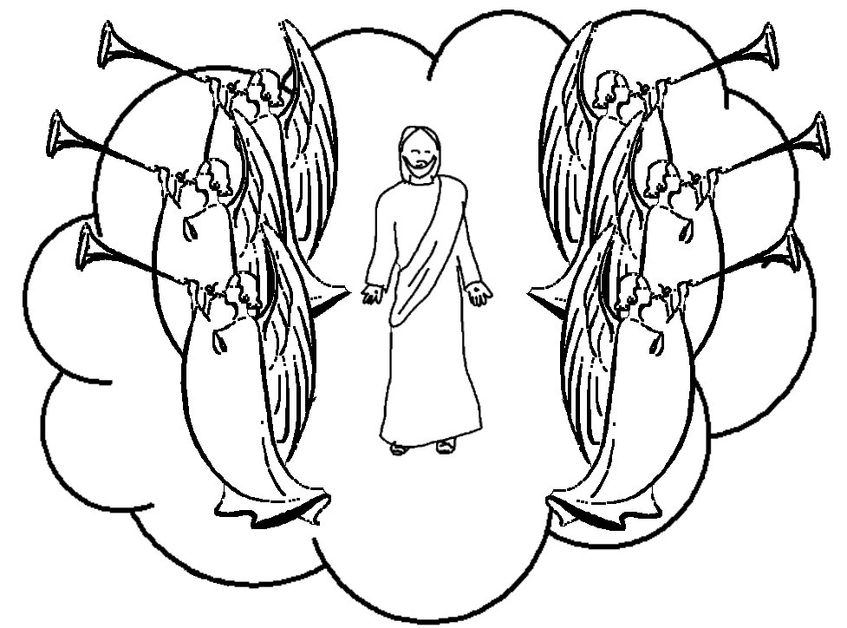

Jesus has been taken from you into heaven, but someday He will return from heaven in the same way you saw Him go!”
Acts 1:11 _{NLT}

